Assignment no: 4
1. Employee and Address
Problem Statement:
Create an Employee class that contains an object of an Address class representing the employee's residential address. The Address class should contain area,city, and PIN code. Accept and display the complete employee and address details.implement constructors.

Concept: Object of one class as a data member of another class.
#include <iostream>
#include <string>

using namespace std;

// Address class to store location details
class Address {
private:
string area;
string city;
string pinCode;

public:

Address(string a, string c, string p) {
area = a;
city = c;
pinCode = p;
}

void displayAddress() const {
cout << "Area: " << area << endl;
cout << "City: " << city << endl;
cout << "PIN Code: " << pinCode << endl;
}
};

class Employee {
private:
string name;
int id;
Address address;

public:

Employee(string empName, int empId, Address empAddress)
: name(empName), id(empId), address(empAddress) {}

void displayEmployeeDetails() const {
cout << "\n--- Employee Details ---" << endl;
cout << "ID: " << id << endl;
cout << "Name: " << name << endl;
cout << "--- Residential Address ---" << endl;
address.displayAddress();
}
};

int main() {
int id;
string name, area, city, pinCode;

cout << "Enter Employee ID: ";
cin >> id;
cin.ignore();

cout << "Enter Employee Name: ";
getline(cin, name);

cout << "Enter Area: ";
getline(cin, area);

cout << "Enter City: ";
getline(cin, city);

cout << "Enter PIN Code: ";
getline(cin, pinCode);

Address empAddress(area, city, pinCode);

Employee emp(name, id, empAddress);

emp.displayEmployeeDetails();

return 0;
}

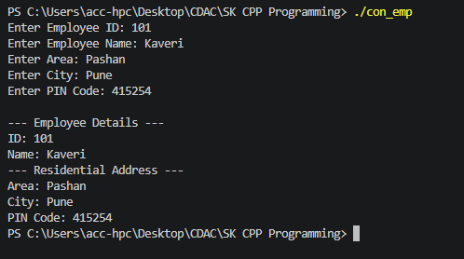

2.Employee and Joining Date
Problem Statement:
Create an Employee class that contains an object of a Date class representing the employee's joining date. The Date class should contain day, month, and year. Accept employee ID, employee name, salary, and joining date, and display all the details.
Concept: Employee has-a Date.
#include <iostream>
#include <string>

using namespace std;

class Date {
private:
int day;
int month;
int year;

public:

Date() : day(1), month(1), year(2000) {}

Date(int d, int m, int y) : day(d), month(m), year(y) {}

// Function to accept date details from the user
void acceptDate() {
cout << "Enter Day (DD): ";
cin >> day;
cout << "Enter Month (MM): ";
cin >> month;
cout << "Enter Year (YYYY): ";
cin >> year;
}

void displayDate() const {
cout << day << "/" << month << "/" << year;
}
};

class Employee {
private:
int empId;
string name;
double salary;
Date joiningDate; // Composition

public:

void acceptEmployeeDetails() {
cout << "Enter Employee ID: ";
cin >> empId;
cin.ignore();

cout << "Enter Employee Name: ";
getline(cin, name);

cout << "Enter Salary: ";
cin >> salary;

cout << "--- Enter Joining Date ---" << endl;
joiningDate.acceptDate();
}

void displayEmployeeDetails() const {
cout << "\n===================================" << endl;
cout << " EMPLOYEE DETAILS " << endl;
cout << "===================================" << endl;
cout << "Employee ID : " << empId << endl;
cout << "Name : " << name << endl;
cout << "Salary : $" << salary << endl;
cout << "Joining Date : ";
joiningDate.displayDate();
cout << endl << "===================================" << endl;
}
};

int main() {
Employee emp;

cout << "Enter details for the employee:" << endl;
emp.acceptEmployeeDetails();

emp.displayEmployeeDetails();

return 0;
}

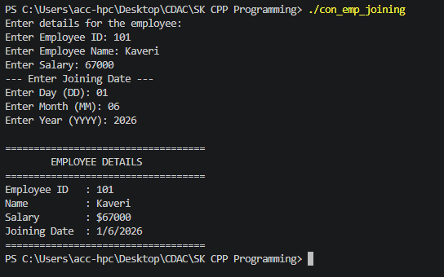

Assignment no: 5

1. Program 1: Complex Number – Operator Overloading
Problem Statement:
Create a Complex class to represent complex numbers using real and imaginary parts. Overload the following operators to perform the corresponding operations on two complex number objects:

+ – Addition of two complex numbers
- – Subtraction of two complex numbers
++ – Pre Increment the real and imaginary parts of a complex number
++ – PostIncrement the real and imaginary parts of a complex number
<< and >> operator
Create appropriate objects and demonstrate the working of all the overloaded operators.
#include <iostream>
using namespace std;

class Complex {
private:
float real;
float img;

public:
// Default and parameterized constructor
Complex(float r = 0, float i = 0) {
real = r;
img = i;
}

// Overload + operator for adding two complex numbers
Complex operator+(const Complex &c) {
return Complex(real + c.real, img + c.img);
}

// Overload - operator for subtracting two complex numbers
Complex operator-(const Complex &c) {
return Complex(real - c.real, img - c.img);
}

// Overload ++ (Pre-increment)
Complex& operator++() {
++real;
++img;
return *this;
}

// Overload ++ (Post-increment)
Complex operator++(int) {
Complex temp = *this;
real++;
img++;
return temp;
}

// Overload >> operator for input
friend istream& operator>>(istream &in, Complex &c) {
cout << "Enter real and imaginary part: ";
in >> c.real >> c.img;
return in;
}

// Overload << operator for clean mathematical output formatting
friend ostream& operator<<(ostream &out, const Complex &c) {
if (c.img >= 0) {
out << c.real << " + " << c.img << "i";
} else {
out << c.real << " - " << -c.img << "i";
}
return out;
}
};

int main() {
Complex c1, c2, result;

// 1. Input testing using overloaded >>
cout << "=== Input Complex Numbers ===\n";
cin >> c1;
cin >> c2;

// 2. Output testing using overloaded <<
cout << "\n=== Initial State ===" << endl;
cout << "c1 = " << c1 << endl;
cout << "c2 = " << c2 << endl;

// 3. Binary operators testing
cout << "\n=== Arithmetic Operations ===" << endl;
result = c1 + c2;
cout << "Addition (c1 + c2) : " << result << endl;

result = c1 - c2;
cout << "Subtraction (c1 - c2) : " << result << endl;

// 4. Pre-increment testing
cout << "\n=== Pre-Increment (++c1) ===" << endl;
cout << "Before increment c1 : " << c1 << endl;
result = ++c1;
cout << "Value returned by (++c1) : " << result << endl;
cout << "After increment c1 : " << c1 << endl;

// 5. Post-increment testing
cout << "\n=== Post-Increment (c2++) ===" << endl;
cout << "Before increment c2 : " << c2 << endl;
result = c2++;
cout << "Value returned by (c2++) : " << result << endl;
cout << "After increment c2 : " << c2 << endl;

return 0;
}

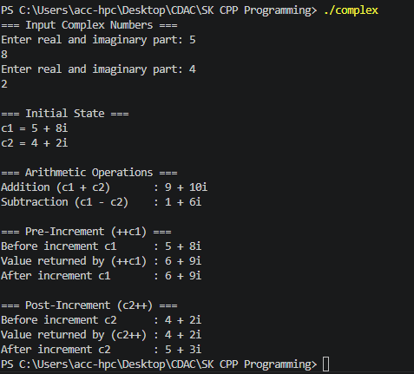

2. Create Array class Implement following.
Accept and Display function
Operator + for adding two arrays.
implement copy constructor.
implement destructor.
overload > operator.
#include <iostream>
using namespace std;

class Array {
private:
int *arr;
int size;

public:
Array(int s = 5) {
size = s;
arr = new int[size];
for (int i = 0; i < size; i++) {
arr[i] = 0;
}
}
Array(const Array &a) {
size = a.size;
arr = new int[size];
for (int i = 0; i < size; i++) {
arr[i] = a.arr[i];
}}

~Array() {
delete[] arr;
}

void accept() {
cout << "Enter " << size << " elements: ";
for (int i = 0; i < size; i++) {
cin >> arr[i];
}
}

void display() const {
for (int i = 0; i < size; i++) {
cout << arr[i] << " ";
}
cout << endl;
}

Array operator+(const Array &other) {
Array temp(size);
for (int i = 0; i < size; i++) {
temp.arr[i] = this->arr[i] + other.arr[i];
}
return temp;
}

bool operator>(const Array &other) {
int sum1 = 0, sum2 = 0;
for (int i = 0; i < size; i++) {
sum1 += this->arr[i];
}
for (int i = 0; i < other.size; i++) {
sum2 += other.arr[i];
}
return sum1 > sum2;
}
};

int main() {
int size;
cout << "Enter size for the arrays: ";
cin >> size;

Array a1(size);
cout << "For Array 1:" << endl;
a1.accept();

Array a2(size);
cout << "For Array 2:" << endl;
a2.accept();

cout << "\nArray 1: ";
a1.display();
cout << "Array 2: ";
a2.display();

cout << "\nCreating Array 3 as a copy of Array 1..." << endl;
Array a3 = a1;
cout << "Array 3 (Copy of Array 1): ";
a3.display();

Array a4 = a1 + a2;
cout << "\nArray 4 (Array 1 + Array 2): ";
a4.display();

if (a1 > a2) {
cout << "\nArray 1 is greater than Array 2 (has a larger sum)." << endl;
} else {
cout << "\nArray 1 is not greater than Array 2." << endl;
}

return 0;
}

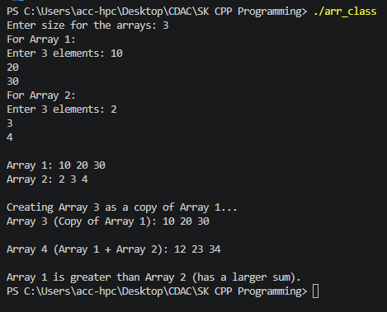

3. Create circle class with data member pi and redius.
1.Declare pi as const data member
2.implement display and getRedius function as const function
3. create const object and invoke all functions.
#include <iostream>
using namespace std;

class Circle{
const float pi;
float red;
public:
Circle(int r):pi(3.14f){
red=r;
}

double getRadius() const{
return red;
}

void Display() const{
cout << "Pi : " << pi <<endl;
cout << "Radius : " << red <<endl;
cout << "Area of Circle : " << (pi*red*red) <<endl;
}

};

int main()
{
const Circle c1(2);

cout << "Radius : " << c1.getRadius() << endl;

c1.Display();
return 0;
}

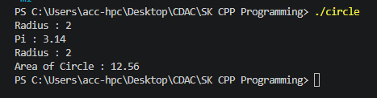

4. create class Person (age, name)
inherite person class and create student class with data member rno,and percentage.
create appropriate objects and invoke functions.
#include <iostream>
using namespace std;

class person {
int age;
string name;
public:
person () {
age = 21;
name = "Kaveri";
}

person (string name, int age){
this -> name = name;
this-> age = age;
}

void Display(){
cout<< "\n\t name:"<< name;
cout<<"\n\t age:"<< age;
}
};

class Std : public person{
int Rno;
float percentage;
public: Std(){
Rno = 15;
percentage = 95;
}
Std(int i, float perc, int age, string name):person(name, age){
Rno = i;
percentage = perc;
}
void Display() {
person::Display();
cout << "\n\t Roll No:" << Rno;
cout << "\n\t Percentage:" << percentage << "%" << endl;
}
};

int main(){
person p1;
p1.Display();
Std s1;
s1.Display();
return 0;
}

